**IT24102949**

**Siriwardana D.D**

**Lab sheet 05**

**Exercise**

1. Import the dataset (’Exercise – Lab 05.txt’) into R and store it in a data frame called ”Delivery Times”.





1. Draw a histogram for deliver times using nine class intervals where the lower limit is 20 and upper limit is 70. Use right open intervals. 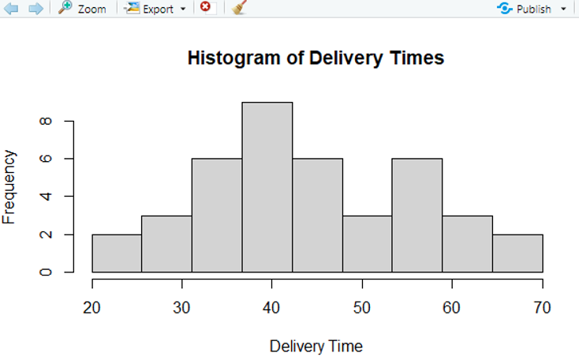
2. Comment on the shape of the distribution

**Modality:** The histogram shows a single prominent peak near 40 minutes, which means the distribution is unimodal.

**Symmetry:** The data distribution appears roughly symmetric around the central value of 40 minutes, as both sides of the histogram are fairly balanced.

**Skewness:** There is no obvious skewness present. The frequencies taper off evenly on both sides, suggesting the data is approximately normally distributed.

**Spread:** Delivery times range from about 20 to 70 minutes, but the majority of observations lie between 30 and 50 minutes. The highest concentration is around 40 minutes, indicating a moderate spread.

1. Draw a cumulative frequency polygon (ogive) for the data in a separate plot. 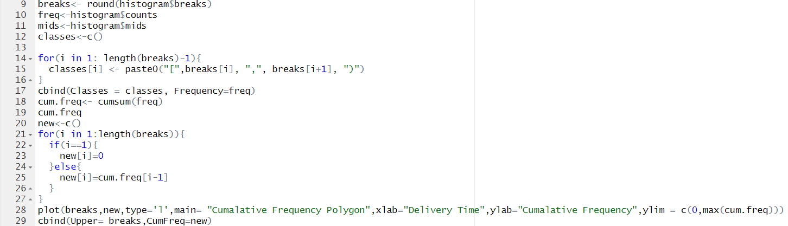 A screenshot of a computer program

   AI-generated content may be incorrect. A close-up of a computer screen

   AI-generated content may be incorrect. A graph on a computer screen

   AI-generated content may be incorrect.